Date: ……………………….…

# SUPERVISOR’S RECOMMENDATION

It is my pleasure to recommend that a report on “Online School Admission System” has been prepared under my supervision by **Bibek Poudel and Supriya Shrestha** in partial fulfillment of the fourth semester for System Analysis and Design of Bachelor of Information and Communication Technology(BICT), Institute of Information and Communication Technology, Tribhuvan University. This report is satisfactory and is an original work done by them to process for the future evaluation.

………………………………….

**Mr. Ghan Bahadur Thapa**

Project Supervisor

Aadikavi Bhanubhakta Campus

# ACKNOWLEDGEMENT

We would like to acknowledge all the individuals who have helped and supported us throughout the project. We would like to express our special thanks to our project Supervisor **Mr. Ghan Bahadur Thapa** sir, who gave us golden opportunity to do this wonderful project on the "Online School Admission System" and guide us throughout the project by providing all the necessary ideas, information and knowledge for the project. We would like to thanks our project members for trusting each members and helping each other by sharing ideas and giving proper comments and suggestions. This project has helped us in doing lots of research. It has been a source to learn and bring our theoretical knowledge to real-life world.

We would also like to express our thanks to Aadikavi Bhanubhakta Campus for providing all the necessary infrastructure and friendly environment for completion of the project. We would like to thanks **Mr. Maha Prashad Hadkhale**, Chief, Aadikavi Bhanubhakta for his moral support towards completing our project work. Without his support, the project would not have been completed.

Lastly, we would like to thanks our classmates who provided us with valuable suggestions to improve our project.

**Bibek Poudel(7628804)**

**Supriya Shrestha(76288025)**

# ABSTRACT

We propose an Online School Admission System.

**Table of Contents**

SUPERVISOR’S RECOMMENDATION 1

ACKNOWLEDGEMENT 2

ABSTRACT 3

Table of Figure 6

LIST OF ABBREVIATIONS 6

CHAPTER 1: INTRODUCTION 7

1.1 Problem Statement and Motivation 8

1.2 Objectives 8

1.3 Project Scope and Direction 9

1.4 Limitation 9

1.5 Report Organization 10

CHAPTER 2: REQUIREMENT ANALYSIS 10

2.1 Literature Review 10

2.2 Problem Definition 11

2.3 Proposed Solution 11

2.4 Requirement Analysis 12

2.4.1 Functional Requirement 12

2.4.1 Non-Functional Requirement 16

2.5 Feasibility Analysis 17

2.5.1 Technical Feasibility: 17

2.5.2 Operational Feasibility: 17

2.5.3 Economic Feasibility: 17

2.5.4 Cost Feasibility 18

2.6 Structuring System Requirements 19

2.6.1 Data Modeling (ER-Diagram) 19

2.6.2 Process Modeling (DFD level-0 and DFD level-1) 20

CHAPTER-3: SYSTEM DESIGN 21

3.1 System Architecture and Overview 21

3.2 System Design 21

3.2.1 Database schema 21

3.2.2 Data Dictionary 22

3.2.3 UML Class Diagram 22

3.2.4 UML Activity Diagram 23

3.2.5 UML Sequential Diagram 23

3.2.6 Interface Design 23

CHAPTER-4: IMPLEMENTATION AND TESTING 23

4.1 Implementation and Overview 23

4.2 Tools Used 23

4.2.1 Front End Tools 23

4.2.2 Back End Tools 24

4.3 Testing 24

4.3.1 Unit Testing 24

4.3.2 Integrated Testing 24

4.3.1 System Testing 24

CHAPTER 5: CONCLUSION AND RECOMMENDATION 25

5.1 Conclusion 25

REFERENCE 25

# Table of Figure

Figure 1: Use case Diagram 13

Figure 2: Use Case Template (I) 15

Figure 3: Use Case Template (II) 16

Figure 4: Entity Relationship Diagram 19

Figure 5: Data Flow Diagram Level – 0 20

Figure 6: Data Flow Diagram Level – 1 21

# LIST OF ABBREVIATIONS

|  |  |
| --- | --- |
| HTML | Hypertext Markup Language |
| CSS | Cascading Style sheet |
| PHP | PHP: Hypertext Preprocessor |
| MySQL | Sequential Query Language ( MySQL is a database engine) |
| DFD | Data Flow Diagram |
| ER | Entity Relationship |
| SDLC | Software development Life Cycle |
| GUI | Graphic User Interface |
| RDBMS | Relational Database Management System |

# CHAPTER 1: INTRODUCTION

Online admission system is aimed toward developing an internet admission system for the college students. As with most real world activities, there are numerous benefits to using a software system for admission procedure. The most apparent to this project is the unification of the entire process. Another aspect of a software system is the use of a central database. This database is the basis for all actions in the system and can be trivially updated and used to aid in all of the system’s processes, meaning all of the required information is stored in one central location and thus is easily accessible. This is a far more reasonable storage method than a paper-based file system, where the time of traveling to and physically searching the records for the required information could be a burden. Human error could also be a factor in that mistakes could be made in the filing process which would not occur in a well written database system and mistakes or changes on physical records can be messy to correct. The aim of this planned system is to produce fast online admission.

## 1.1 Problem Statement and Motivation

Due to the manual admission means been used by the schools, keeping the information of the student application, lots of problems are encountered that includes:

1. Delay in processing admission.
2. The work load of the staff is high and the resources are not optimized as well to find the best students.
3. Loss of important documents due to the manual filing system.
4. Damage of document due to fire or weather disasters.
5. Take a lot of time to retrieve a particular application form.
6. Illegal removal of the form by the fraudulent staff leads to insecurity.

## Objectives

To solve the existing problem in the admission system in School. The major objectives of this system is to minimize the time spent maintaining the records of the School admissions process. Our objectives for this process are further divided into two types. They are:

1. **Primary Objective:**
2. To develop the online student admission system that will replace the manual method.
3. To automate the paperless admission process.
4. To save the time wasted with manual method of checking student's information.
5. To make the admission process more flexible and convenient for the applicants.
6. **Secondary Objectives:**
7. To store data with less redundancy.
8. To retrieve the data when necessary.
9. To store and manage large number of student details.
10. To make the entire admission management system process easy to navigate, intuitive and secure.
11. To overcome the problems of reliability, accuracy, searching, updating, modification deletion of record etc.

## Project Scope and Direction

In manual method of admission system, student will buy form, filled it and submit it manually to the admission department and wait for the admission. This online admission system is design to solve the problem affecting the manual process in use. In this system student can visit the website and fill the form for the enrollment and they can view their registration. It is design to be used in the database format thereby relieving both student and the staff from much stress as experienced from manual system. Student information is protected within an application form, where only admin panel has access to it. Students do not need to fill out all of the details when upgrading the class once the data has been entered into the database until the admin deletes the data/details. Therefore, the form's structure should include all the information required for registration.

## 1.4 Limitation

In the rural areas, people may not have access of internet and electricity. All applicants could not have access to the internet or be inexperienced with computers. In terms of security, there is a worry that hackers might target schools and educational institutions in order to exploit the data and information of students. The security risks connected with processing online applications and the protection of student data are key additional concerns. Online applications make it simpler for scammers to falsify the qualifying conditions and application procedure. Beside this, there is no real time communication for feedback.

## 1.5 Report Organization

This project consists of five chapters. These chapters are classified to make documentation of the project more transparent. A brief description about the contents of each chapter is given in the following paragraphs:

**Chapter 1**: This chapter explains the overview, introduction, problem statement, objectives, scope and limitation of the proposed system.

**Chapter 2**: This chapter covers all the history, methods, requirement specification and feasibility analysis and structured system requirements.

**Chapter 3**: Design of online school admission system is explained in detail with all the necessary diagrams and brief functionality.

**Chapter 4**: Defines implementation and testing.

**Chapter 5**: Displays lesson learnt, conclusion and future recommendation.

# CHAPTER 2: REQUIREMENT ANALYSIS

## 2.1 Literature Review

Traditionally admission was taken manually which is very time consuming and often leads to human error. Additionally, there are lots of questions regarding the source of the admission records, even if the most of them are not retrieved from the actual circumstances. It is time-consuming to take admissions for students using the outdated paper-based system. According to the research, there are a variety of solutions to this problem. Use of online admission system for the purpose of admission process is the smart way of admission management system Use of Online admission system allows students to get admit to the school from anywhere and at any time. It is one of the most user-friendly methods of admission of the student. Many school invest heavily in developing such information systems to ensure their school's reliability. This project creates an information system that focuses on inserting, storing, and updating student information. In comparison to previous methods, the online admission approach is more precise, quicker, and less likely to allow for proxy admission.

## 2.2 Problem Definition

The file based student admission system has been very effective for many years. However, with the increasing number of applicant, the system wastes a lot of time in terms of searching for the applicant record and requires large numbers of staff which lead to high cost of operation. Because of the above mentioned, an online application system was created to help school management save time and money. This system helps to store student necessary information into the database system.

Problem of Existing System:

1. Require lots of man power i.e. much efforts, much cost and hard to operate and maintain.

2. Since, all the work is done in papers so it is very difficult to find a particular student record when it is needed.

## 2.3 Proposed Solution

The approach suggested in this paper is online school admission system. The admission is recorded by using an online registration through web application. Online admission system is aimed at developing an online admission form for the school students. The aim of the proposed system is to provide quick online admission. The system is internet-based system which can be accessed throughout from the school as well as from outside. It provides a simple database and a good level of normalization will make sure that the user is getting admitted through the online application. It helps to add multiple records of students easily and minimize the waste of time.

The system has two main parts. They are:

1. Admin
2. User

Student visits website and fill the application form provided by online to apply for the enrollment. School administrator logging is for the admin to access and manage student's information, accept/reject student admission form and monitor the whole process.

## 2.4 Requirement Analysis

### 2.4.1 Functional Requirement

* **Add/Manage students**: Admin can add the student and manage the information of the student.
* **Search information of students:** Student themselves and the admin can search the student information.
* **Login users:** First of all, the user need to register themselves and after the approval of admin then only the users can login to the system.
* **Show all users:** After getting login to the system as the admin, the system show the all users information.
* **Show profile of login user:** When the user get login to the system as the admin then the user can view their profile.
* **Logout:** Only when the user get login to the system as the admin then only the user can get logout of the system.

**Use case Diagram**

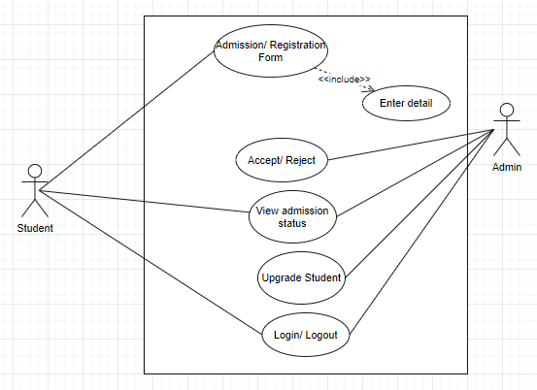

Figure 1: Use case Diagram

**Use case Template**

|  |  |  |  |  |
| --- | --- | --- | --- | --- |
| Use Case ID: | 1.0 | | | |
| Use Case Name: | Admission Form | | | |
| Created By: | Bibek,Supriya | | Last Updated By: |  |
| Date Created: | April 5, 2022 | | Date Last Updated: |  |
| Actor: | | Student | | |
| Description: | | * User provides their detail information for admission purpose | | |
| Preconditions: | | * User must fill up their detail information that are required | | |
| Post conditions: | | * User get logged in to the system | | |
| Normal Case: | | * Registration form is fill up * Filled form is submit * User get the confirmation of registration | | |
| Alternative Course: | | * If user didn’t fill the required data, system don’t accept the form | | |
| Exception: | | * Admission form get rejected | | |
| Includes: | | * Enter detail | | |
| Priority: | | * High | | |
| Frequency of Use: | | * Every time during the admission | | |
| Business Rule: | |  | | |
| Special Requirements: | | * Registration form must be filled up | | |
| Assumptions: | |  | | |
| Notes and Issues: | | * Detail information of students is required | | |
| Use case Graphics: | |  | | |

Figure 2: Use Case Template (I)

|  |  |  |  |  |
| --- | --- | --- | --- | --- |
| Use Case ID: | 2.0 | | | |
| Use Case Name: | Login/Logout of system | | | |
| Created By: | Bibek, Supriya | | Last Updated By: |  |
| Date Created: | 30th October,2022 | | Date Last Updated: |  |
| Actor: | | Admin | | |
| Description: | | User login with the valid username and password to further access the system | | |
| Preconditions: | | User must use valid login username and password | | |
| Pot conditions: | | User is logged in to the system | | |
| Normal Case: | | 1. System displays login page 2. User enter username and password 3. System redirect the user to the dashboard | | |
| Alternative Course: | | If user enter invalid credentials, system displays error messages | | |
| Exception: | | Not registered account | | |
| Includes: | | Enter valid username, password | | |
| Priority: | | High | | |
| Frequency of Use: | | Every time when system is used | | |
| Business Rule: | |  | | |
| Special Requirements: | | Valid username and password | | |
| Assumptions: | |  | | |
| Notes and Issues: | | Don’t forget username and password | | |
| Use case Graphics: | |  | | |

Figure 3: Use Case Template (II)

### 2.4.1 Non-Functional Requirement

* **Performance:** The proposed website should identify users and students smoothly.
* **Security:** The proposed website must be secure from unethical attacks like unauthorized access of the website.
* **Reliability:** The website must be reliable so that admin should able to conform username and password of authorize users.
* **Maintainability:** Website must be maintainable when failure occur.
* **Availability:** Website must be available whenever required.

## Feasibility Analysis

* + 1. Technical Feasibility:

 For both end users and developers our project requires a simple hardware i.e. a computer or a laptop with normal processing speed and a good internet connection. Our system will be compatible for any type of operating system. Our system can be  enhanced & modules can be upgraded due to the object-oriented programming  approach. All the requirements can be easily available so we must say it is technically feasible.

**Tools used**: Visual Studio Code, XAMPP, Apache server, MySQL database, Bootstrap.

**Hardware Requirement:** Laptop

* + 1. Operational Feasibility:

For the system to work functionally, basic computer knowledge, web site knowledge and power supply is necessary which is abundant in every organization and also as we mentioned earlier only few technologies will be used to operate the website and simple training demonstration of working website will be required for admin so it is operationally feasible.

### **2.5.3 Economic Feasibility:**

As our project needs computers and some open source software which can be easily available through internet surfing and are free of cost, the implementing cost will be very low compared to other websites with different hardware requirement systems and which uses premium software for development. Admin can operate our system with less effort, save a significant amount of time and only few technologies are required so the cost of manpower is not a necessity that’s why it is economically feasible. Since, our system does not use any other extra or exceptional hardware components, it will be cheap and economically efficient.

|  |  |  |
| --- | --- | --- |
| S.N. | Particulars | Amount |
| 1. | Software | Rs 1,000 |
| 2. | Paper print cost | Rs 800 |
| 3. | Per person | Rs 500 * 3 = Rs 1500 |
| 4. | Internet cost | Rs 5000 |
|  | Total cost | Rs.8,300 |

### Cost Feasibility

This cost feasibility is a part of economic feasibility study. Here, we estimate the cost involved for developing the project and possible benefit of this project. As we have used the computer with the access of internet to run the system Admin look after the system and manage the student records. As it is economically feasible, the annual maintenance cost is affordable.

**Techniques for assessing Cost Feasibility:**

1. **Payback analysis**

It helps to determine the payback period of our investment. Payback period is the time required to earn back the amount invested with the cash flow derived from our project. Suppose our initial investment is around Rs.60000 then then the positive annual cash flow is about Rs.200000 then the payback period is 0.05 years.

1. **Return on Investment**

It is the financial measurement of profitability. It is the percentage rate that measures what actual return on investment realized. It is the ratio between the next return of investment and the cost of the investment. It allocates the net income to the project.

## 2.6 Structuring System Requirements

Structuring System Requirements mainly focus in definition, structure and relationship within data. The characteristics of data captured during data modeling are crucial in the design of databases, programs, computer screens and printed information is essential in ensuring data integrity in an information system.

### 2.6.1 Data Modeling (ER-Diagram)

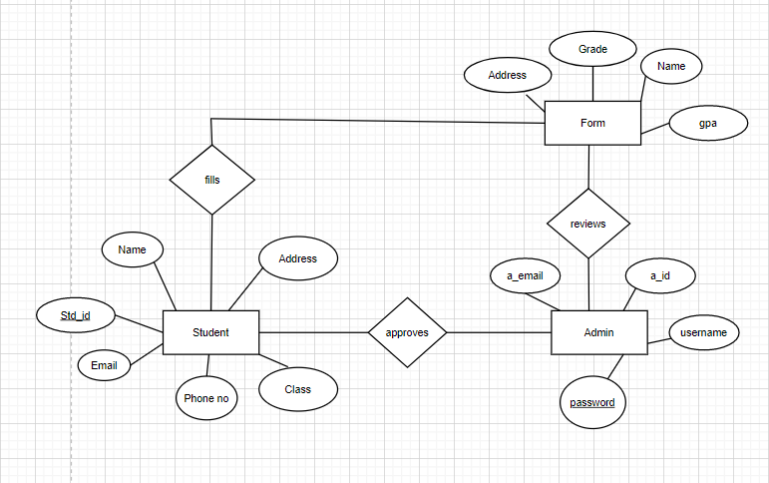

Figure 4: Entity Relationship Diagram

The above diagram explains the relationship between the databases where rectangle represents entity, oval represents attributes and diamond represents relation. There are three entities with their respective attributes. Admin acts as one of the entities and has attributes like admin_id, username and password.

### 2.6.2 Process Modeling (DFD level-0 and DFD level-1)

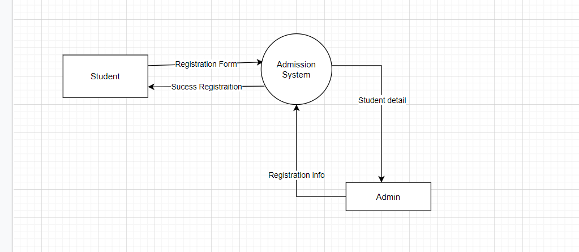

Figure 5: Data Flow Diagram Level – 0

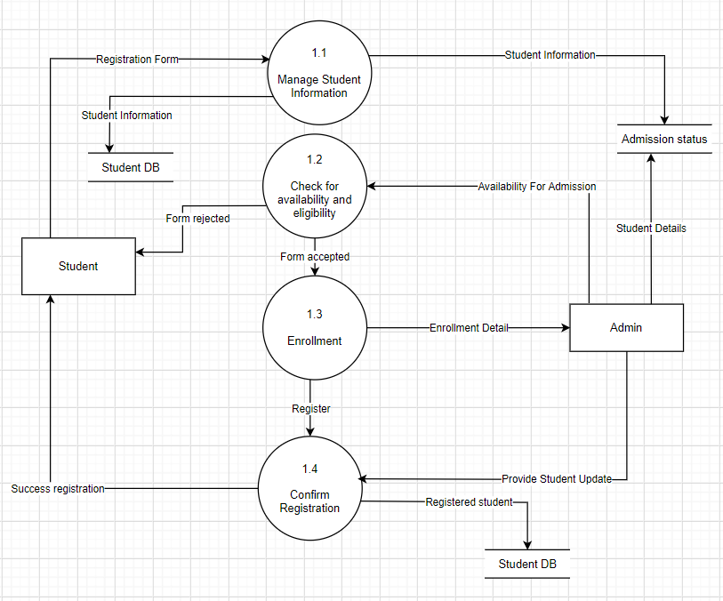

Figure 6: Data Flow Diagram Level – 1

# CHAPTER-3: SYSTEM DESIGN

## 3.1 System Architecture and Overview

## 3.2 System Design

### 3.2.1 Database schema

### 3.2.2 Data Dictionary

### 3.2.3 UML Class Diagram

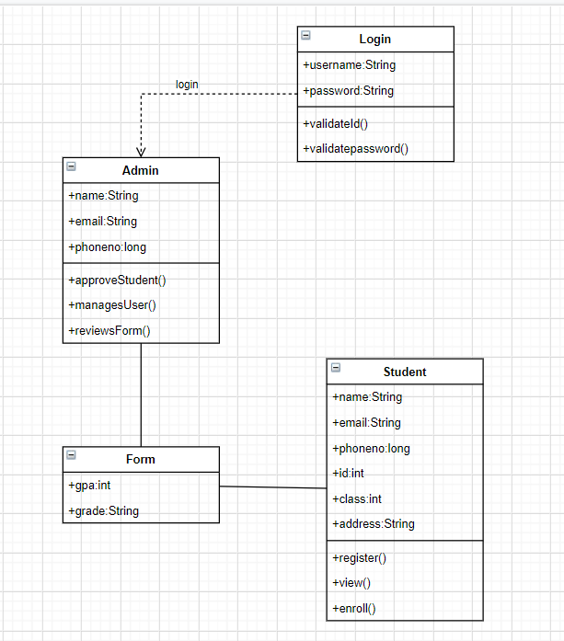

Figure 7: UML Class Diagram

### 3.2.4 UML Activity Diagram

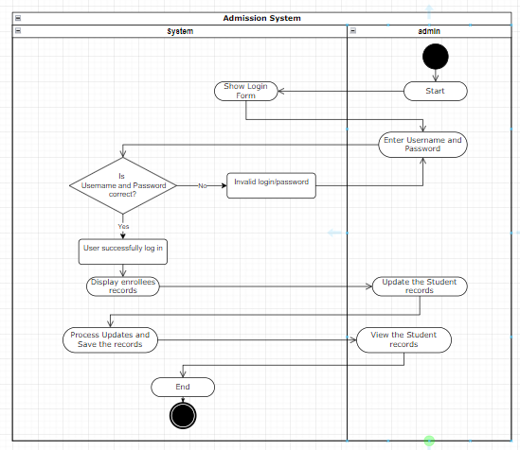

### 3.2.5 UML Sequential Diagram

### 3.2.6 Interface Design

# CHAPTER-4: IMPLEMENTATION AND TESTING

## 4.1 Implementation and Overview

## 4.2 Tools Used

### 4.2.1 Front End Tools

* HTML, CSS, Bootstrap, JavaScript
* HTML: HTML is used to create and save web document.
* CSS: (Cascading Style Sheets) Create attractive Layout.
* Bootstrap: Responsive design mobile friendly site.
* JavaScript: It is a programming language, commonly use with web browsers.

### 4.2.2 Back End Tools

* ++PHP: Hypertext Preprocessor (PHP) is a technology that allows software developers to create dynamically generated web pages, in HTML, XML, or other document types, as per client request. PHP is open source software.
* MySQL: MySQL is a database, widely used for accessing querying, updating, and managing data in databases.
* IDE: VSS Code

## 4.3 Testing

### 4.3.1 Unit Testing

### 4.3.2 Integrated Testing

### 4.3.1 System Testing

# CHAPTER 5: CONCLUSION AND RECOMMENDATION

## 5.1 Conclusion

The "Online Admission System" aims to automate the Admission process and its related operations and functions at Academic schools. The system's supports the administrator and the students with the support needed to make admission process easy, faster and hassle-free experience in all concerned. The administrator, user and system are the three key modules in this system. The manual method has been improved. The system's computerization has increased process speed. This system takes care of all the requirements of the admission system and provide easy and effective way to apply for admission and learn information of the school, courses and facilities that are present in the school.

# REFERENCE

Vi, B. C. A. S. (n.d.). *PROJECT REPORT ON ONLINE ADMISSION SYSTEM FOR SCHOOL*. *11032211193*, 1–58.